**SODING: INDIVIDUAL ASSIGNMENT**

* Build a web page to implement a payment page according to image below.

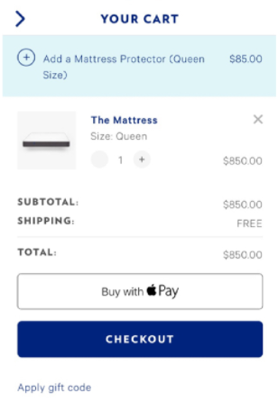

* Screenshot the program output.
* Put all the codes into GITHUB.
* Email us the details to [nurdin@soding.com.my](mailto:nurdin@soding.com.my).

**Rules**

* **Due date: 2 days after you received this assignment.**
* **Make sure you can code in between 1 - 3 hours.**
* **Plagiarism is not allowed.**

**Soding Analysis Report**

**REPORT**

|  |  |
| --- | --- |
| **Candidate Name** | Suleman Waseem |
| **Github Repository** | https://github.com/suleman1128/shopping-cart |
| **Resume Link (Google Drive)** | https://drive.google.com/open?id=0B02x6zZzYSVUNjJvN0ZDZU9fNXc |

**PERFORMANCE REPORT**

|  |  |
| --- | --- |
| **Static Code Analysis** | |
| **Result** | <<leave_it_blank>> |
| **Predictive Analysis** | |
| **Result** | <<leave_it_blank>> |
| **Personality Analysis** | |
| **Result** | <<leave_it_blank>> |

**REASON**

|  |  |
| --- | --- |
| **Why you want to find a new job? (minimum 200 words)** | Because I want learn more with new technologies and tools I want to improve my self in any organization/company. |

**CANDIDATE DETAILS**

|  |  |  |  |
| --- | --- | --- | --- |
| **Phone Number** | +92-3218565998 | **Total Experience (Years)** | 1 year |
| **Skill Set (Programming Language)** | Php, Html, Css, Csharp | **Current Employer** | Web developer |
| **Current Job Title** | internee | **Current Salary** | 25000 pkr |
| **Expected Salary** | 1000$ monthly | **Current Location** | Pakistan |

**SCREENSHOTS**

